**SQL JOINS**

The SQL JOIN statement is used to combine rows from two tables based on a common column and selects records that have matching values in these columns.

**Example**

-- join the Customers and Orders tables

-- based on the common values of their customer_id columns

SELECT Customers.customer_id, Customers.first_name, Orders.item

FROM Customers

JOIN Orders

ON Customers.customer_id = Orders.customer_id;

[Run Code](https://www.programiz.com/sql/online-compiler)

Here, the SQL command joins the Customers and Orders tables based on the common column, customer_id of both tables.

The result set will consist of

* customer_id and first_name columns from the Customers table
* item column from the Orders table

**SQL JOIN Syntax**

SELECT columns_from_both_tables

FROM table1

JOIN table2

ON table1.column1 = table2.column2

Here,

* table1 and table2 are the two tables that are to be joined
* column1 is the column in table1 that is related to column2 in table2

**Example: Join Two Table Based on Common Column**

-- join Customers and Orders tables based on

-- customer_id of Customers and customer column of Orders

SELECT Customers.customer_id, Customers.first_name, Orders.amount

FROM Customers

JOIN Orders

ON Customers.customer_id = Orders.customer;

[Run Code](https://www.programiz.com/sql/online-compiler)

Here, the SQL command selects the columns:

* customer_id and first_name from the Customers table
* amount from the Orders table

The result set will contain those values where there is a match between customer_id (of the Customers table) and customer (of the Orders table).

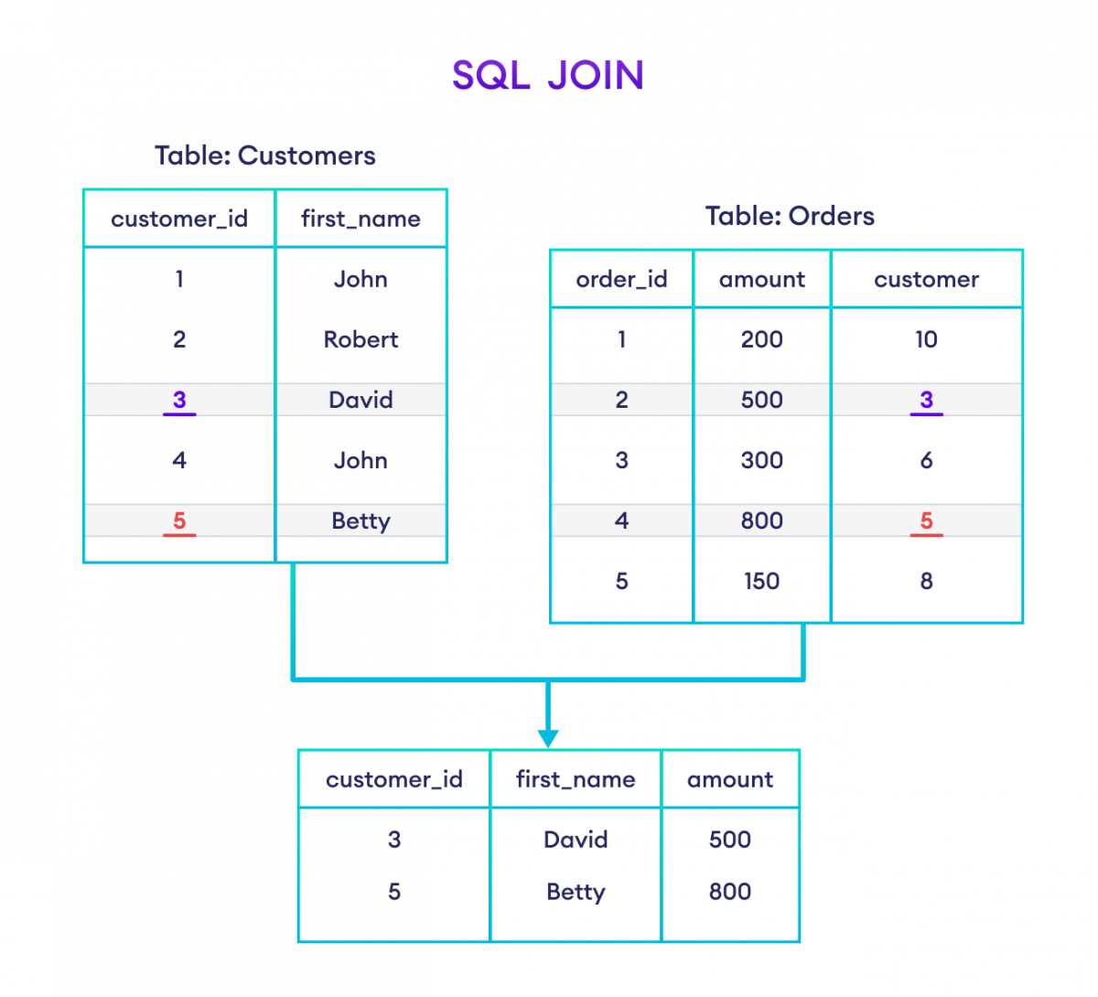Join Two Table Based on Common Column

**JOIN Multiple Tables**

We can also join more than two tables using JOIN. For example,

-- join three tables: Customers, Orders, and Shippings

SELECT Customers.first_name, Orders.item, Shippings.status

FROM Customers

JOIN Orders ON Customers.customer_id = Orders.customer_id

JOIN Shippings ON Customers.customer_id = Shippings.customer;

[Run Code](https://www.programiz.com/sql/online-compiler)

This SQL command joins three tables and selects relevant columns from each, based on the matching customer_id.

**Note:** To learn more about how to join multiple tables, visit [SQL Join Multiple Tables](https://www.programiz.com/sql/join-three-tables).

**Types of SQL JOINs**

In SQL, we have four main types of joins:

* [INNER JOIN](https://www.programiz.com/sql/inner-join)
* [LEFT JOIN](https://www.programiz.com/sql/left-outer-join)
* [RIGHT JOIN](https://www.programiz.com/sql/right-join)
* [FULL OUTER JOIN](https://www.programiz.com/sql/full-outer-join)

SQL Self JOIN

In SQL, the Self JOIN operation allows us to join a table with itself, creating a relationship between rows within the same table.

Let's look at an example.

SELECT

C1.first_name AS FirstPerson,

C2.first_name AS SecondPerson,

C1.country

FROM Customers C1, Customers C2

WHERE C1.country = C2.country AND C1.first_name != C2.first_name;

The SQL query will return pairs of customers who are from the same country but have different first names.

SQL JOIN With AS Alias

We can use [AS aliases](https://www.programiz.com/sql/select-as-alias) with table names to make our query short and clean. For example,

-- use alias C for Customers table

-- use alias O for Orders table

SELECT C.customer_id, C.first_name, O.amount

FROM Customers AS C

JOIN Orders AS O

ON C.customer_id = O.customer;

Here, the SQL command joins the Customers and Orders tables while assigning the aliases **C** and **O** to them, respectively.

Also, we can change the column names temporarily using AS aliases. For example,

-- use alias C for Customers table

-- use alias O for Orders table

SELECT C.customer_id AS cid, C.first_name AS name, O.amount

FROM Customers AS C

JOIN Orders AS O

ON C.customer_id = O.customer;

Apart from giving aliases to the tables, the SQL command above also assigns aliases to the columns of the Customers table:

* customer_id column has the alias cid
* first_name column has the alias name
* JOIN With WHERE Clause
* Here's an example of JOIN with the [WHERE](https://www.programiz.com/sql/select#sql-where) clause:
* -- join Customers and Orders table with matching fields customer_id and customer
* SELECT Customers.customer_id, Customers.first_name, Orders.amount
* FROM Customers
* JOIN Orders
* ON Customers.customer_id = Orders.customer
* WHERE Orders.amount >= 500;
* Here, the SQL command joins two tables and selects rows where the amount is greater than or equal to **500**.
* 